Lab2- AWS Storage Service(EBS)

2.2-🡪 Create an EBS Volume and attach to the existing EC2 instance and mount this secondary volume to store data.

Step 1: Open the EC2 dashboard and select the Volumes option from the dashboard present in the left panel.

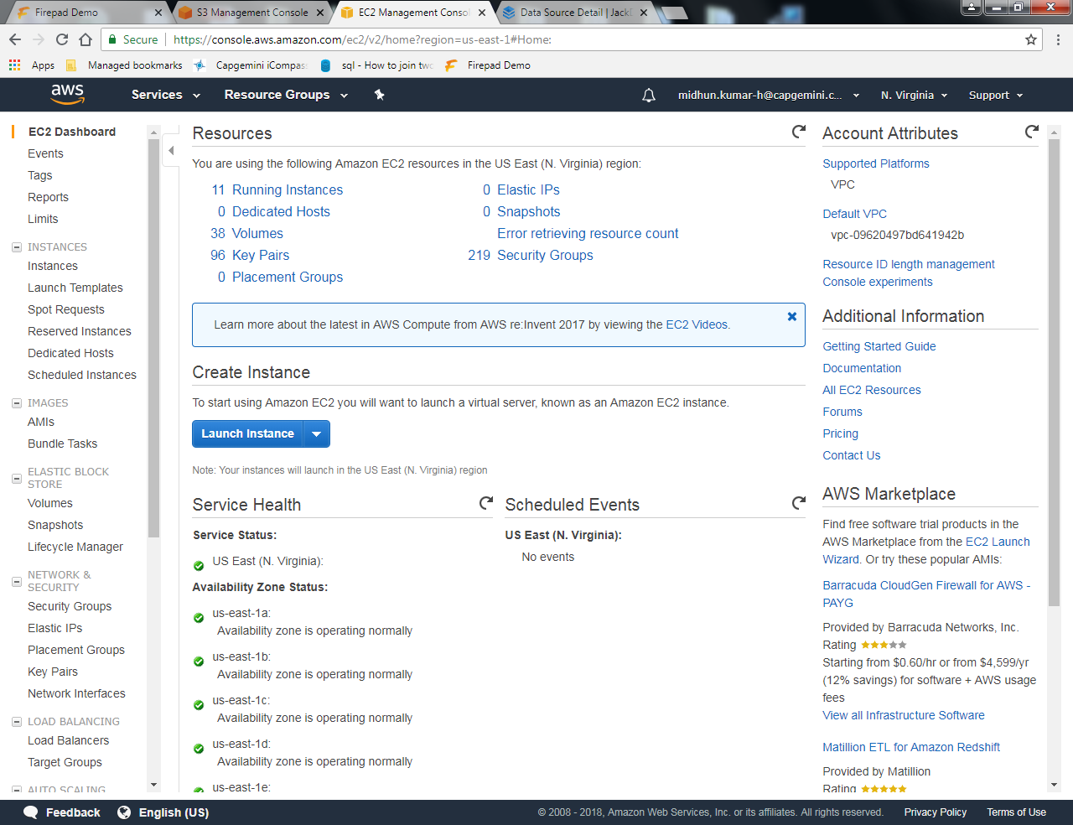

Step 2: On Clicking the Volumes, we need to select the create volume.

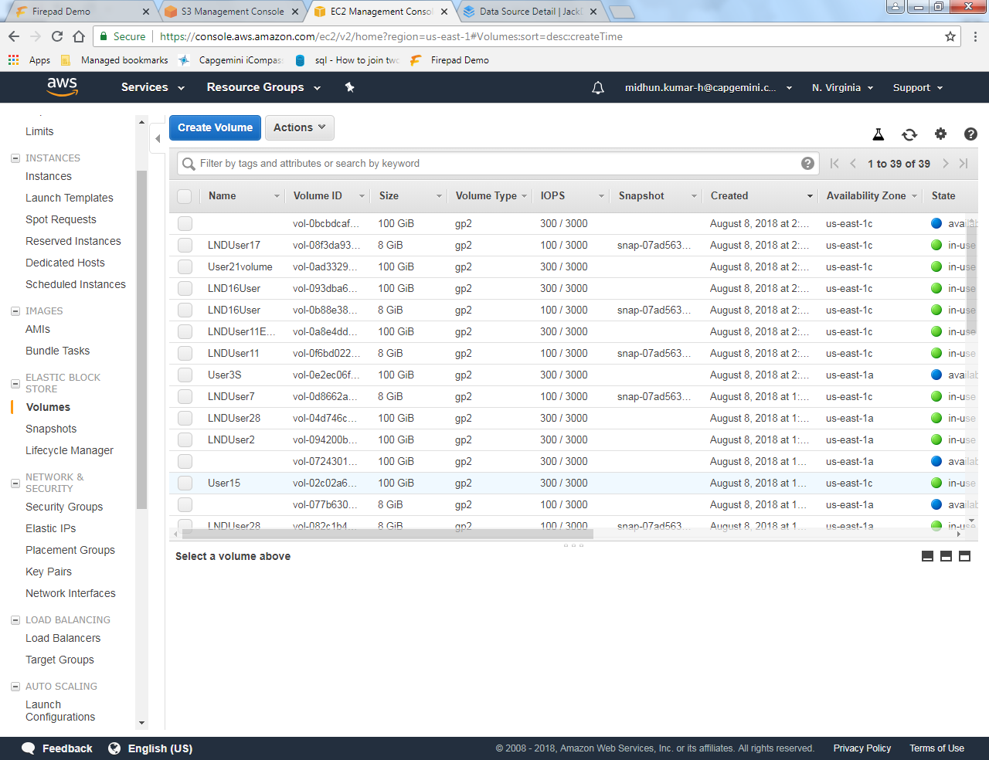

Step 3: While creating the volume, we need to give the availability zone.

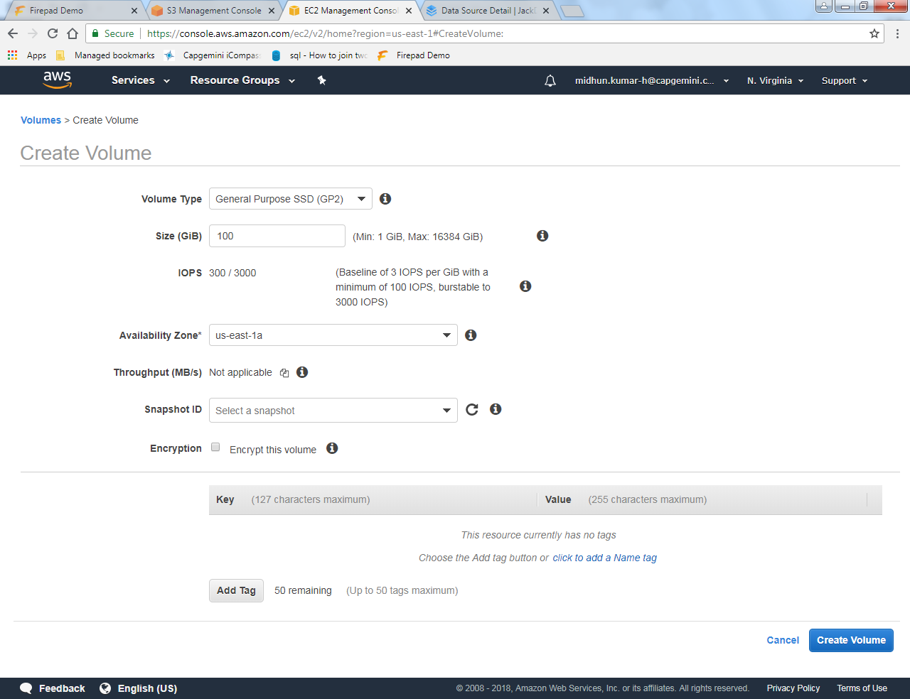

Step 4: Select the availability zone and then add tags like name, company, etc,.

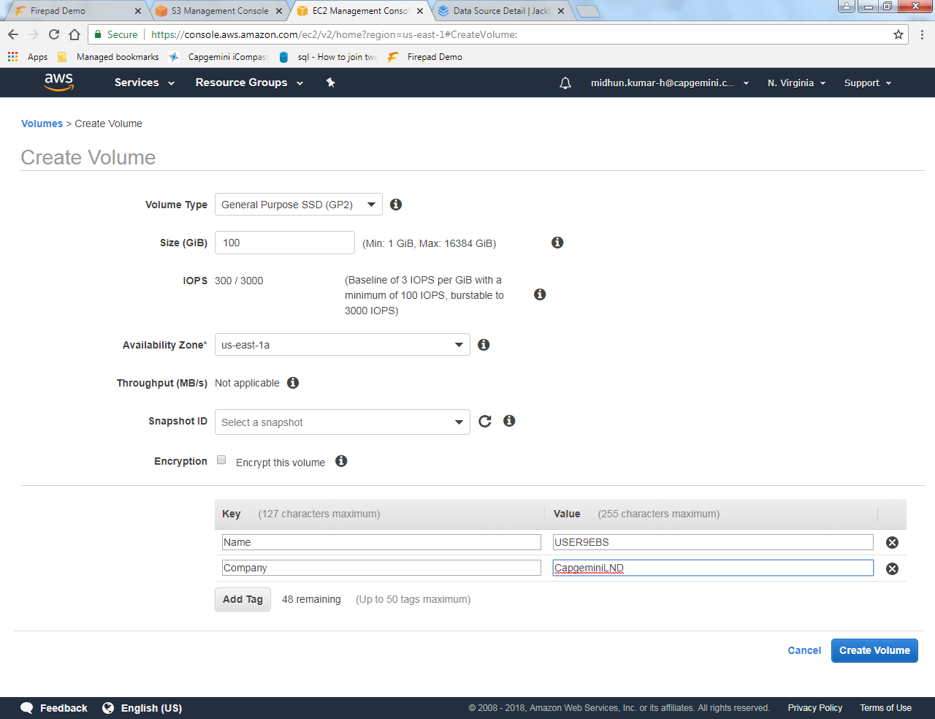

Step 5: Use an appropriate format for the names that you mention.

Step 6: Once you click create volume, we get a notification page saying that “Volume has been generated successfully”.

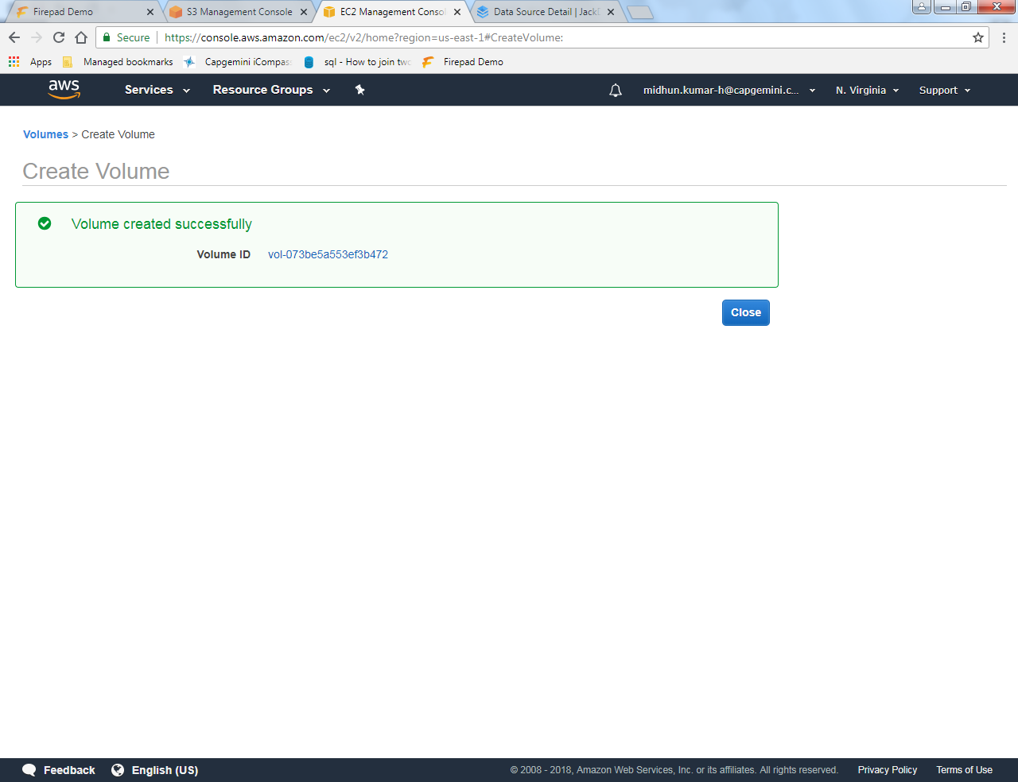

Step 7: Now click on the volume id shown in that page and then from actions, select attach volume.

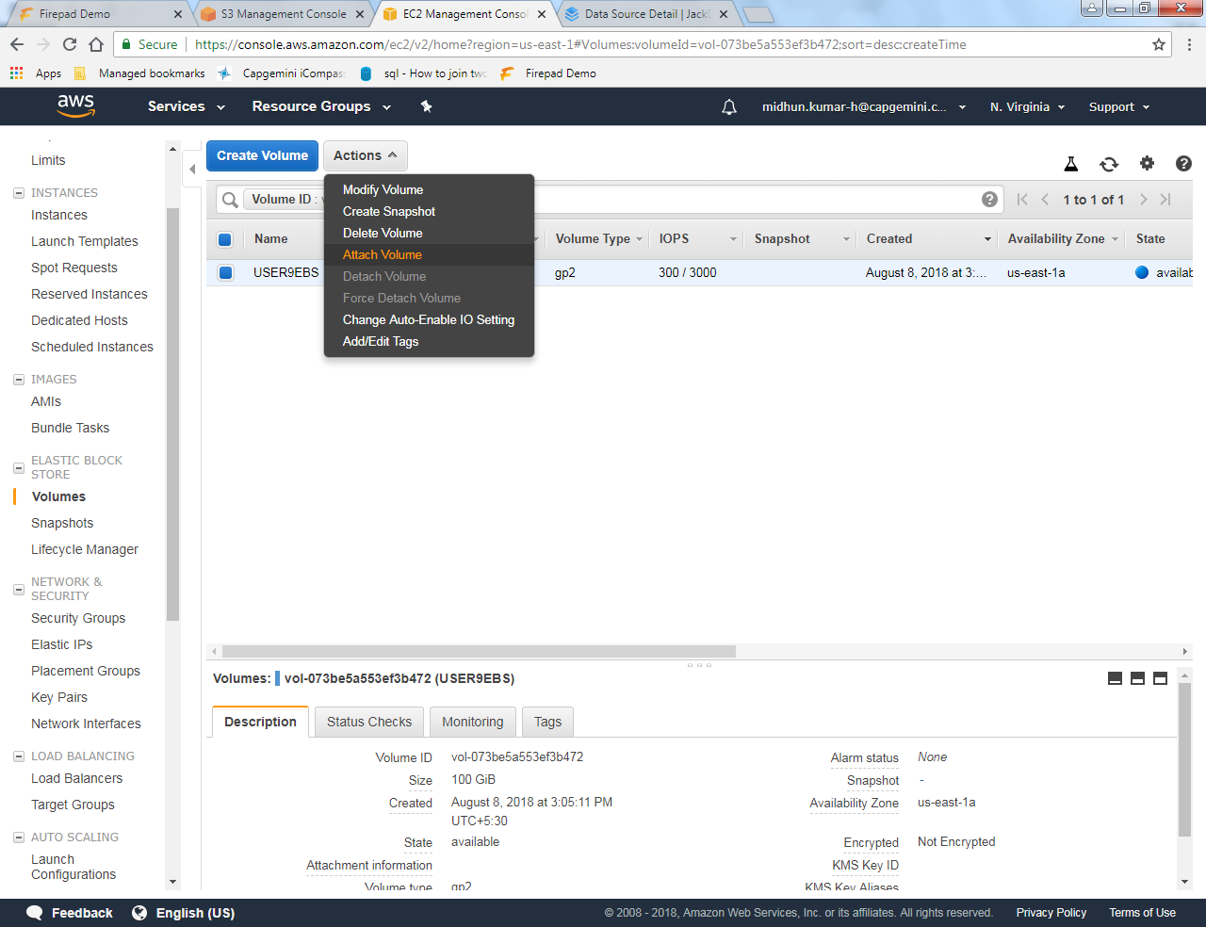

Step 8: Select the instance and the device.

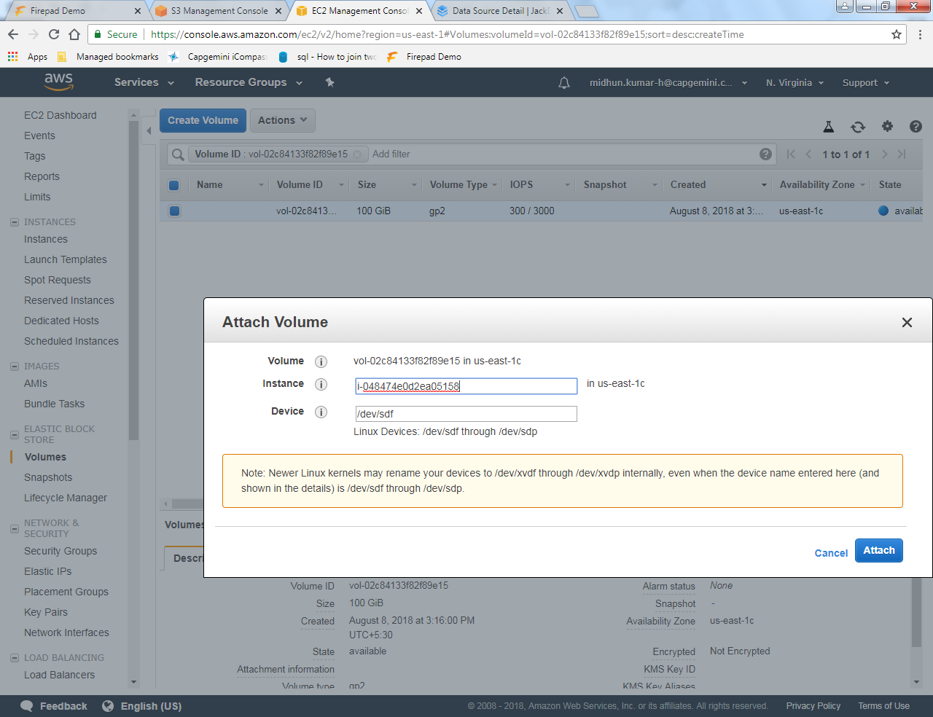

Step 9: Open the putty with the host name based on your instance.

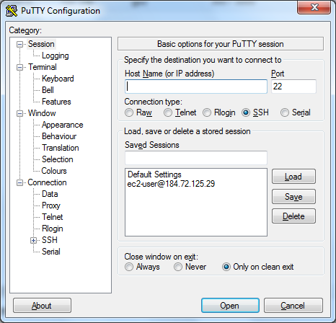

Step 10: Write the command 🡪 $ lsblk.

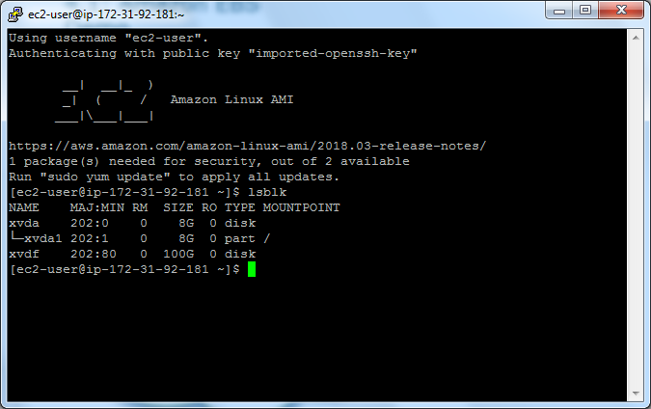

Step 11: Write the command 🡪 $ sudo file –s /dev/xvda.

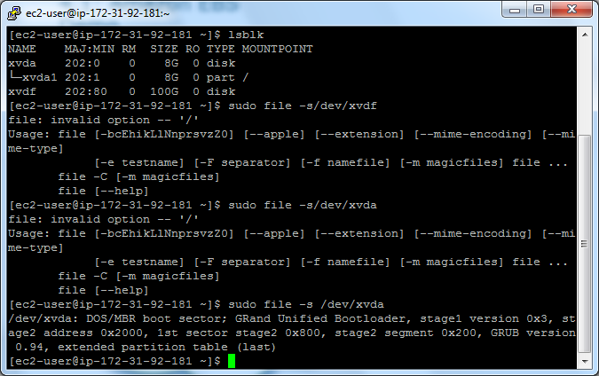

Step 12: Write the command 🡪 $ sudo file –s /dev/xvda1.

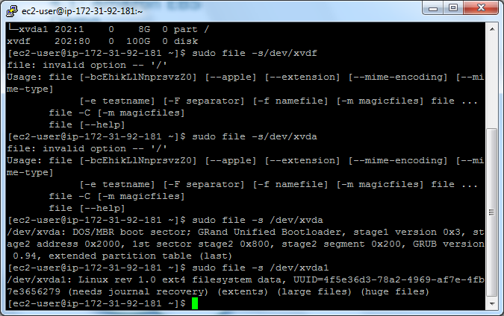

Step 13: Write the command 🡪 $ sudo mkfs –t ext4 /dev/xvda🡪type y for yes.

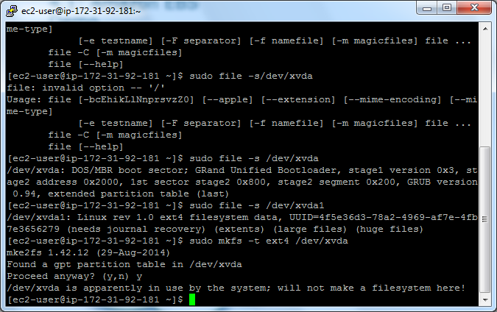

Step 14: Write the command 🡪 $ sudo mkdir/data.

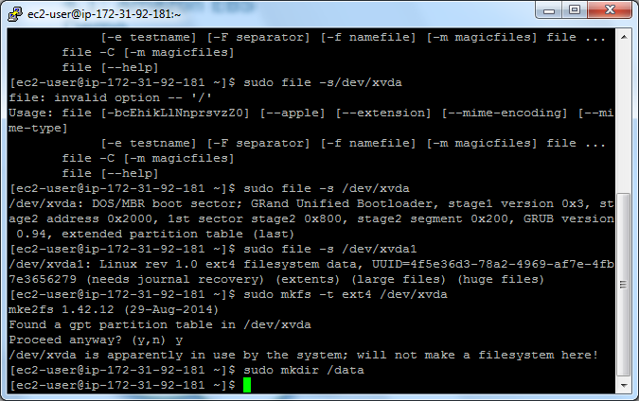

Step 15: On typing the above command, we get the desired output as shown below.

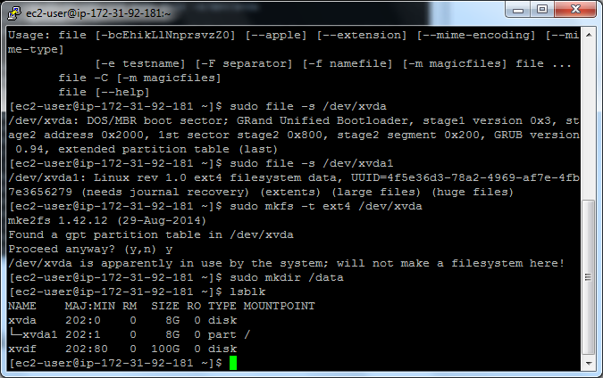

\*\*\*\*\*\*\*\*\*\*\*\*\*\*\*\*\*\*\*\*\*\*\*\*\*\*\*\*\*\*\*\*\*\*\*\*The END\*\*\*\*\*\*\*\*\*\*\*\*\*\*\*\*\*\*\*\*\*\*\*\*\*\*\*\*\*\*\*\*\*\*\*\*\*\*\*\*\*\*